Chapter 6, Problem 47.

For the circuit in Fig. 6.70, calculate the value of R that will make the energy stored in the capacitor the same as that stored in the inductor under dc conditions.

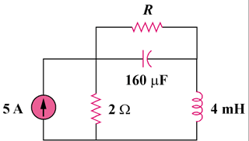

Figure 6.70
For Prob. 6.47.

